**Metrics, Logs and Traces**

* Metrics: Metrics are numeric time-series data.

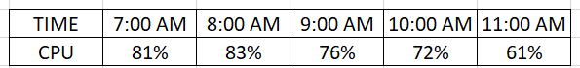

* Logs :
  + Logs are text information with no standard way/format.
  + Logs from different applications/servers
    - Apache 192.168.2.20 - - [28/Jul/2006:10:27:10 -0300] "GET /cgi-bin/try/ HTTP/1.0" 200 3395
    - <https://www.ossec.net/docs/log_samples/> for some other applications
  + For logs we deal with text (unstructured data)
  + using logs requires a solution to
    - convert unstructured text in semi structured
    - understand logs with various format
    - Log analysis solution
* Traces:
  + APM (Application Performance Monitoring) Agents can help
* We are trying to make our applications observable
* Monitoring tells you when something is wrong, while observability enables you to understand why.
* Tools  
  